Title of the article
Vorname Nachname ¹, Vorname2 Nachname2²*, Vorname3 Nachname3²
¹Universität XY, Institut für Musterkonstruktion, 01234 Musterstadt
²Firma XY GmbH, 01234 Musterstadt
*Corresponding author. E-Mail address: muster.vorname@universitätxy.de; Tel.:01254/45896217

Abstract (200 words): Lorem ipsum dolor sit amet, consetetur sadipscing elitr, sed diam nonumy eirmod tempor invidunt ut labore et dolore magna aliquyam erat, sed diam voluptua. At vero eos et accusam et justo duo dolores et ea rebum. Stet clita kasd gubergren, no sea takimata sanctus est Lorem ipsum dolor sit amet. Lorem ipsum dolor sit amet, consetetur sadipscing elitr, sed diam nonumy eirmod tempor invidunt ut labore et dolore magna aliquyam erat, sed diam voluptua. At vero eos et accusam et justo duo dolores et ea rebum. Stet clita kasd gubergren, no sea takimata sanctus est Lorem ipsum dolor sit amet. Lorem ipsum dolor sit amet, consetetur sadipscing elitr, sed diam nonumy eirmod tempor invidunt ut labore et dolore magna aliquyam erat, sed diam voluptua. At vero eos et accusam et justo duo dolores et ea rebum. Stet clita kasd gubergren, no sea takimata sanctus est Lorem ipsum dolor sit amet.
Duis autem vel eum iriure dolor in hendrerit in vulputate velit esse molestie consequat, vel illum dolore eu feugiat nulla facilisis at vero eros et accumsan et iusto odio dignissim qui blandit praesent luptatum zzril delenit augue duis dolore te feugait nulla facilisi. Lorem ipsum dolor sit amet, consectetuer.
Keywords:
3-5 Keywords, Keyword 1, Keyword 2

Overview of Content
A article has been created to present the current findings of your research. The text is to be written in the given format template without making any changes to the formatting. The article must be written in american english and must be uploaded as a file in Word format (*.pdf or *.pdf) via the conference management program Indico at “https://indico.uni-paderborn.de/event/126/”.

Content structure
When submitting your scientific article, it is important to present the topic succinctly and purposefully in a concise introduction. The relevance of the topic as well as its professional context should be clearly worked out and the contribution should be clearly assigned to one of the four tracks of the symposium. From this motivation, derive the central research problem and emphasize the originality of your research question and its scientific relevance. If possible, consciously distinguish your topic from related fields of research and formulate at least one concrete research question that forms the core of your analysis.
The methodological approach should be described clearly and comprehensibly. Explain which methods or approaches you used to answer your research question. Then present the key findings of your study and discuss them in a comprehensible manner. Depending on the type of research, these may be study results, concepts or the testing of a hypothesis. To underline the relevance of the research results, the use of a visualization in the form of a table, diagram or figure is mandatory.
In summary, the structure of your article comprises the following points:
- Maximum length of ten pages (including title page and bibliography)
- The abstract must not exceed 800 characters, including spaces.
- derivation of the research problem, emphasis on originality and relevance, formulation of a concrete research question
- clearly described methods and approach
- presentation and discussion of the central results with visualizations such as a table, diagram or figure
- reference list with citation style “Engineering Reports” (e.g. [1–4])
- for the article to be published, at least one author must be registered to participate in the symposium by February 11, 2026

Requirements for the article
The article must fulfill binding minimum requirements. It must not exceed ten pages (including title page and bibliography). Due to the blind review process, the article must be submitted completely anonymously. Personal information such as the name or other references to the authors must not be included.

Formatting requirements
Images must always be centered and labeled with the “HIPPE image” format template. The caption is always placed below the image in a single line. The “HIPPE caption” is used for formatting.
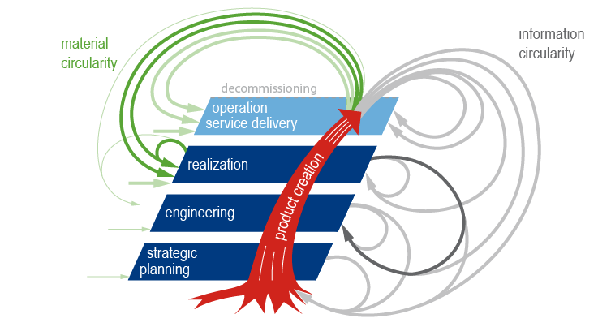
Figure 1: The generic product life cycle [5]

Each table should be displayed centered. The table content is formatted using the “HIPPE table” style sheet. The table caption is placed above the table, it should be in one line if possible and use the “HIPPE table caption” style. A blank line is inserted below each table using the “HIPPE table blank line” style.
Table 1: Example table 1
advantages | disadvantages

For the title of the references, use the format “HIPPE literature heading”, whereby the individual sources are listed with the format “HIPPE literature”.

References
[1] R. Stark, K.-D. Thoben, D. Gerhard, H. Hick, E. Kirchner, R. Anderl, S. Wartzack, F.-L. Krause, I. Grässler, J. Pottebaum, B. Schleich, R. Stelzer, H. u. K. Hick, P. u. K. Klein, B. u. K. Saske, C. Czwick, S. Gogineni, L. Klimmeck, M. Bajzek, G. Jacobs, J. Berroth, T. Zimmermann, P. Kranabitl and N. Göckel, WiGeP Positionspapier - Digitaler Zwilling, 2020.
[2] S. Vajna, ed., Integrated Design Engineering. Interdisziplinäre und ganzheitliche Produktentwicklung, 2. Auflage (Berlin, Heidelberg: Springer Vieweg, 2022).
[3] VDI/VDE, VDI 2206 Entwicklung mechatronischer und cyber-physischer Systeme (2206) (Düsseldorf: Beuth Verlag GmbH, 2021).
[4] D. D. Walden, G. J. Roedler, K. Forsberg, R. D. Hamelin and T. M. Shortell, Systems engineering handbook. A guide for system life cycle processes and activities, 5th ed.San Diego,CA, USA: Wiley, 2023.
[5] I. Gräßler and J. Pottebaum, “Generic Product Lifecycle Model: A Holistic and Adaptable Approach for Multi-Disciplinary Product–Service Systems,” Applied Sciences, vol. 11, no. 10, p. 4516, 2021. DOI: https://doi.org/10.3390/app11104516.

