Format Template HIPPE 2026

Overview of content
An extended abstract is created to present the main content of your academic paper. The text is to be written in the given format template without making any changes to the formatting. The paper must be written in English and must be uploaded as a file in Word format (*.doc or *.docx) via the conference management program Indico at “https://indico.uni-paderborn.de/event/126/”.

Content structure
When submitting your scientific abstract, it is important to present the topic succinctly and purposefully in a concise introduction. The relevance of the topic as well as its professional context should be clearly worked out and the contribution should be clearly assigned to one of the four tracks of the symposium. From this motivation, derive the central research problem and emphasize in particular the originality of your research question and its scientific relevance. If possible, consciously distinguish your topic from related fields of research and formulate at least one concrete research question that forms the core of your analysis.
The methodological approach should be described clearly and comprehensibly. Explain which methods or approaches you used to answer your research question. Then present the key findings of your study and discuss them in a comprehensible manner. Depending on the type of research, these may be study results, concepts or the testing of a hypothesis. To underline the relevance of the research results, the use of a visualization in the form of a table, diagram or figure is mandatory.
Finally, you should include a bibliography with at least five relevant sources that document your thorough examination of the topic.
In summary, the structure of your abstract comprises the following points:
- concise and targeted introduction with location in the symposium track
- derivation of the research problem, emphasis on originality and relevance, formulation of a concrete research question
- clearly described methods and approach
- presentation and discussion of the central results with a visualization such as a table, diagram or figure
- reference list with at least five relevant sources

Requirements for the abstract
The extended abstract must fulfill binding minimum requirements. It must not exceed two pages (including all figures, tables and references). Due to the blind review process, the abstract must be submitted completely anonymously. Personal information such as the name or other references to the authors must not be included.

Formatting requirements
Images must always be centered and labeled with the “HIPPE image” format template. The caption is always placed below the image in a single line. The “HIPPE caption” is used for formatting.
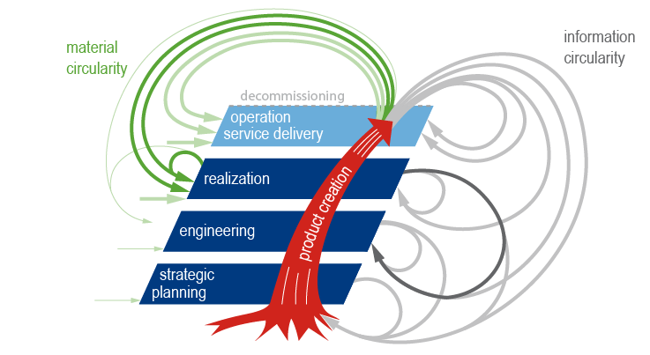
Figure 1: The generic product life cycle [1]
Table 1: Example table 1
advantages | disadvantages

Each table should be displayed centered. The table content is formatted using the “HIPPE table” style sheet. The table caption is placed above the table, it should be in one line if possible and use the “HIPPE table caption” style. A blank line is inserted below each table using the “HIPPE table blank line” style.
For the title of the bibliography, use the format “HIPPE literature heading”, whereby the individual sources are listed with the format “HIPPE literature”.
References
- Gräßler, I.; Pottebaum, J. Generic Product Lifecycle Model: A Holistic and Adaptable Approach for Multi-Disciplinary Product–Service Systems. Appl. Sci. 2021, 11, 4516. https://doi.org/10.3390/app11104516Norm DIN EN ISO 614-1, 2009. Sicherheit von Maschinen – Ergonomische Gestaltungsgrundsätze.

